**A Proposal for Prevention of School Shootings**

William J. Walsh, PhD of Walsh Research Institute

Robert A. deVito, MD

January 10, 2013

**Background**

There have been more than 40 school shootings in the USA since 1990. If no effective action is taken, many more innocent children will die in the next few years. In the wake of the Newtown, Connecticut massacre of 20 children and six adults, the two most frequently offered solutions are (a) getting rid of the guns, and (b) keeping guns away from mentally-challenged persons. Although well-intentioned, both of these solutions would take many years to become effective.

1. Gun Control: There are more than 300 million guns in the USA and more than a third of all families have a gun in the house. Effectively reducing the number of guns in the USA would require many years, even if lawmakers could agree to limit access to guns.
2. Keeping guns away from mentally-challenged persons: There are millions of children and adults in the USA who develop anxiety and depression. Some of these persons have owned guns prior to development of their mental problems. Many more live in a household with guns belonging to others. Although a significant percentage of depressives become suicidal, very few are motivated to visit schools and murder children. It would be impossible to identify the rare individuals who have this inclination.
3. Conclusion: Neither of the above two “solutions” could effectively prevent school shootings for several years. In the meantime, many more children and educators will die.

**A Proposal for Rapid and Efficient Prevention of School Shootings**

Examination of prior school shootings reveals that most of the offenders did not exhibit violent behaviors during their formative years, and many were excellent students. Their problems developed after treatment with antidepressants or other powerful medications. These drugs have helped millions of persons, but psychiatrists have known for years that a rare side effect involves development of suicidal ideation and in some cases homicidal tendencies. For example, SSRI antidepressants obtained from pharmacies contain an insert that warns of “possible development of suicidal ideation”. There is considerable published literature that indicates young males are especially at risk for this side effect. Table 1 shows examples of school shootings in which the offender was being treated with an antidepressant or other psychiatric medication.

Mainstream psychiatry’s “treatment of choice” for depression is use of SSRI antidepressants aimed at increasing serotonin activity in the brain, perhaps coupled with counseling. However, my biochemical study of 2,800 depression patients shows that depression is not a single condition, but an umbrella term that encompasses several quite different disorders (1). Figure 1 shows the five major biochemical types of depression. Greater than 50% of these depression patients exhibited low serotonin activity and reported good response to SSRI antidepressants. In contrast, most depressives in the low-folate group reported worsening depression and anxiety after an antidepressant. In most cases these persons stoppedcompliance after discovering that the drug made their condition worse. In some unfortunate cases, the patient fails to report the worsened depression to the doctor, and the result is suicide.

Another danger of antidepressant drugs is sudden non-compliance. Long-term use of SSRI drugs alters the population of serotonin receptors by a mechanism called “down-regulation”. Persons who suddenly stop an antidepressant may experience severe drug-withdrawal and become suicidal. There are several cases of school shootings in which the crime occurred soon after the offender stopped his medication.

Unique Biochemistry of Persons Intolerant to Antidepressants: More than 90% of depressives who experience symptom worsening after antidepressants exhibit a combination of high methyl and low folate levels in blood. Inexpensive lab testing can identify these persons who must avoid SSRI antidepressants. It seems likely that most school shooters had the low-folate form of depression and experienced an adverse reaction to antidepressant treatment. These persons respond better to benzodiazepine medications, and also benefit from nutrient therapy to elevate folate levels. This approach is based on biochemical studies of 2,800 persons diagnosed with clinical depression, and is described in the new book **Nutrient Power(1)**.

**Specific Recommendation**

Doctors should perform blood testing prior to prescribing antidepressants, especially for young males. Inexpensive testing for whole-blood histamine and blood serum folate levels can efficiently identify persons at risk for suicidal ideation and violence.

1. Walsh WJ (2012). *Nutrient Power.* Skyhorse Publishing, New York, NY.

William J. Walsh, PhD

Walsh Research Institute

Naperville, IL

www.walshinstitute.org

Robert A. deVito, MD

Professor Emeritus

Department of Psychiatry

Loyola University - Stritch School of Medicine

**Figure 1: Five Major Biochemical Types of Depression**

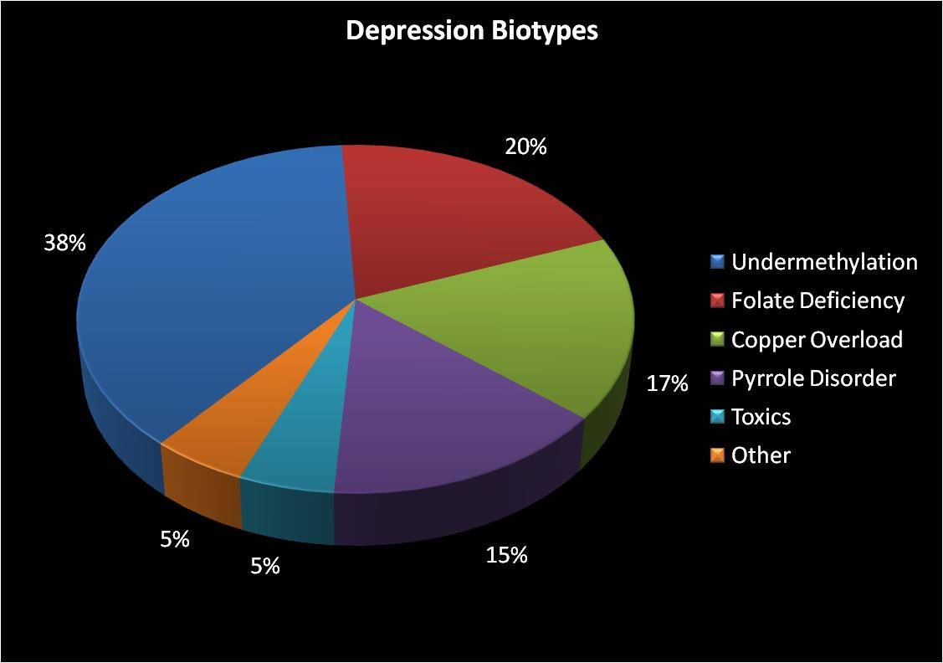

**SCHOOL VIOLENCE BY OFFENDERS TREATED WITH ANTIDEPRESSANTS**

|  |  |  |  |  |  |  |  |
| --- | --- | --- | --- | --- | --- | --- | --- |
| **DATE** | | **OCCURRENCE** | | **LOCATION** | | **DRUG** | |
| 5/20/1988 | | 29 yr. old woman kills 1 child and wounds 5 at elementary school; kills self | | Illinois | | Anafranil Antidepressant | |
| 1/30/1992 | | Teacher shoots and kills his superintendent at school | | Michigan | | Prozac Antidepressant | |
| 9/20/1992 | | Man angry over daughter’s report card shoots 14 rounds wounding 2 police officers inside elementary school | | Texas | | Antidepressants | |
| 10/12/1995 | | 15 yr. old shoots 2 teachers, killing one, then kills himself | | South Carolina | | Zoloft Antidepressant | |
| 4/14/1998 | | 14 yr. old teen in school holds police at bay, fires shots | | Idaho | | Zoloft Antidepressant | |
| 5/21/1998 | | 17 yr. old teen kills 2 students and wounds over 20 at high school after killing parents | | Oregon | | Prozac Antidepressant Withdrawal | |
| 4/16/1999 | | 15 yr. old teen fires two rounds of gunfire in school | | Idaho | | Antidepressant | |
| 4/20/1999 | | COLUMBINE H.S.: 2 senior high school students shoot and kill 12 students and 1 teacher; 24 additional students wounded; commit suicide | | Colorado | | Luvox/Zoloft Antidepressants | |
| 3/10/2001 | | 14 yr. old girl shoots and wounds classmate at Catholic school | | Pennsylvania | | Paxil Antidepressant | |
| 3/22/2001 | | 18 yr. old teen opens fire at classmates in high school wounding 3 students and 2 teachers; later commits suicide while in jail | | California | | Celexa and Effexor Antidepressants | |
| 4/15/2001 | | 16 yr. old teen holds 23 classmates and a teacher hostage with gun at high school | | Washington | | Paxil and Effexor Antidepressants | |
| 6/8/2001 | | Man kills 8 children and wounds 15 other pupils and teachers in elementary school; assailant had taken 10 times his normal dose | | Japan | | Antidepressants | |
| 1/16/2002 | | 43 yr. old law student kills dean, law professor and 1 student, and wounds 3 students at law school | | Virginia | | Possible SSRI Withdrawal Mania | |
| 3/24/2005 | | 10 dead; 7 wounded; dosage increased one week before rampage | | Minnesota | | Prozac Antidepressant | |
| 8/30/2006 | | 19 yr. old teen opens fire at high school wounding 2 students after killing his father at home; Celexa found among his personal effects | | North Carolina | | Celexa Antidepressant | |
| 4/16/2007 | | VIRGINIA TECH: Sr. College student shoots and kills 32; 23 are wounded; commits suicide | | Virginia | | Evidence of Antidepressant Use (SSRI) | |
| 11/6/2007 | | Student kills 8 and wounds 10; kills self at high school | | Finland | | SSRI Antidepressant – Withdrawal Suspected | |
| 1/25/2008 | | 16 yr. old student fires at students and shoots teacher in leg at high school | | New York | | Paxil Antidepressant | |
| 2/14/2008 | | College grad student kills 5 students and wounds 20 in university classroom; commits suicide | | Illinois | | Prozac Withdrawal | |
| 2/20/2008 | | 16 yr. old kills self at high school; lockdown by police | | Idaho | | Med for Depression | |
| 9/23/2008 | | 22 yr. old Finnish student shoots and kills 9 students before killing self | | Finland | | SSRI | |
| 1/23/2009 | | 20 yr. old kills 2 babies and a caregiver at school day care and injures 12 others including 10 children | | Belgium | | Treatment for Depression and Strattera | |
| 3/11/2009 | | 17 yr. old in treatment for depression kills 9 students and 3 teachers at secondary school as well as 3 pedestrians; commits suicide | | Germany | | Antidepressant | |
| 11/10/2009 | | Man with gun inside middle-senior high school holds principal hostage | | New York | | Cymbalta Antidepressant Withdrawal | |
| 2/5/2010 | | 14 yr. old kills fellow middle school student | | Alabama | | Zoloft Antidepressant and ADHD Med | |
| 9/21/2011 | | 14 yr. old teen shoots school official; pipe bombs found in backpack | | South Carolina | | Meds for Depression and ADHD | |
| 10/24/2011 | | 15 yr. old girl stabs 2 girls in school restroom; 1 nearly dies | | Washington | | Med for Depression | |
|  | |  | |  | |  | |
| **DATE** | | **RELATED INCIDENTS** | | **LOCATION** | | **DRUG** | |
| 7/20/2012 | | COLORADO MOVIE THEATER: 24 yr. old grad student kills 12 people; 70 wounded | | Colorado | | Not Yet Determined | |
| 12/14/2012 | | SANDY HOOK ELEMENTARY: 20 yr. old kills 20 children and 6 staff members at school after killing his mother at home; commits suicide | | Connecticut | | Not Yet Determined | |